Output of Product Detail Portal

1.when we run our program

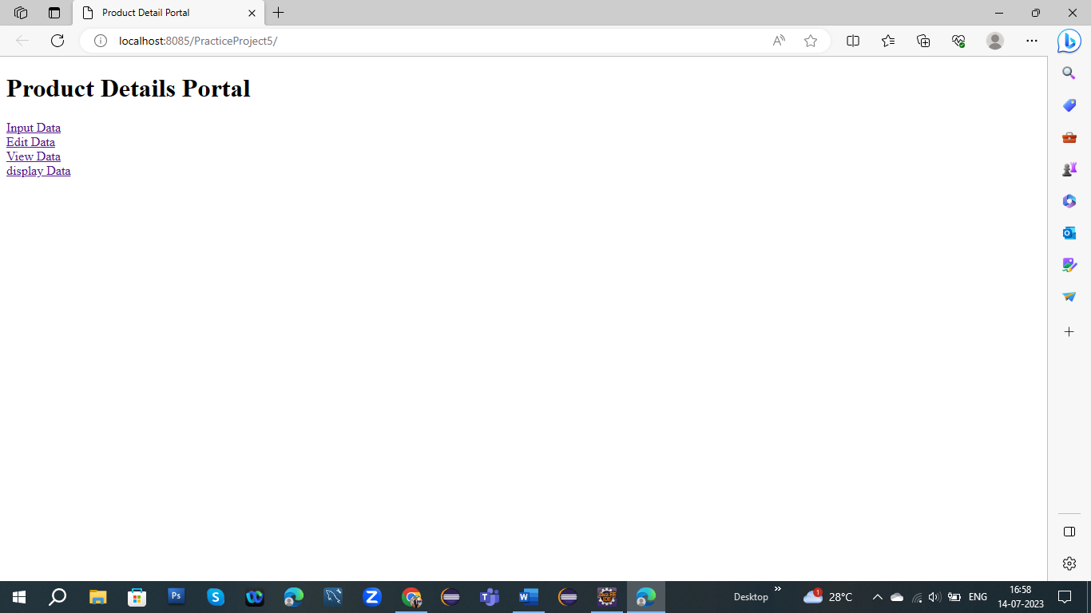2.When we give input data in product detail

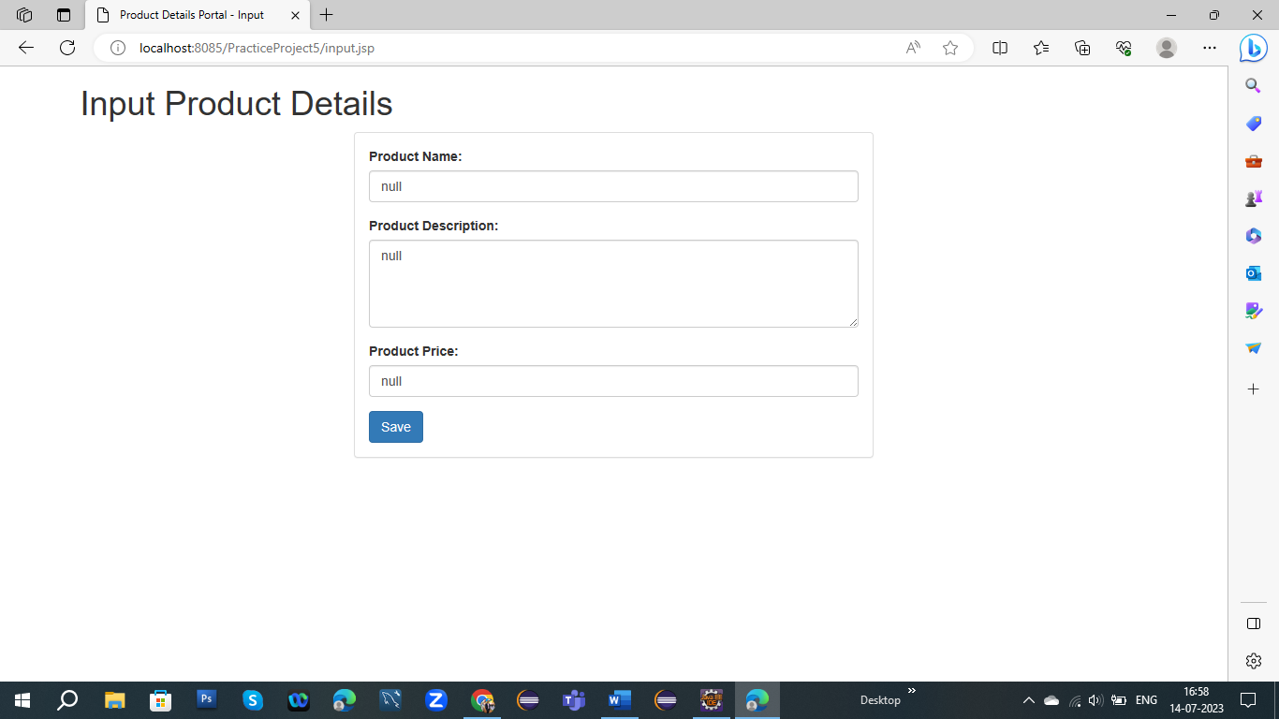

3.After putting data then I check data is my correct or not

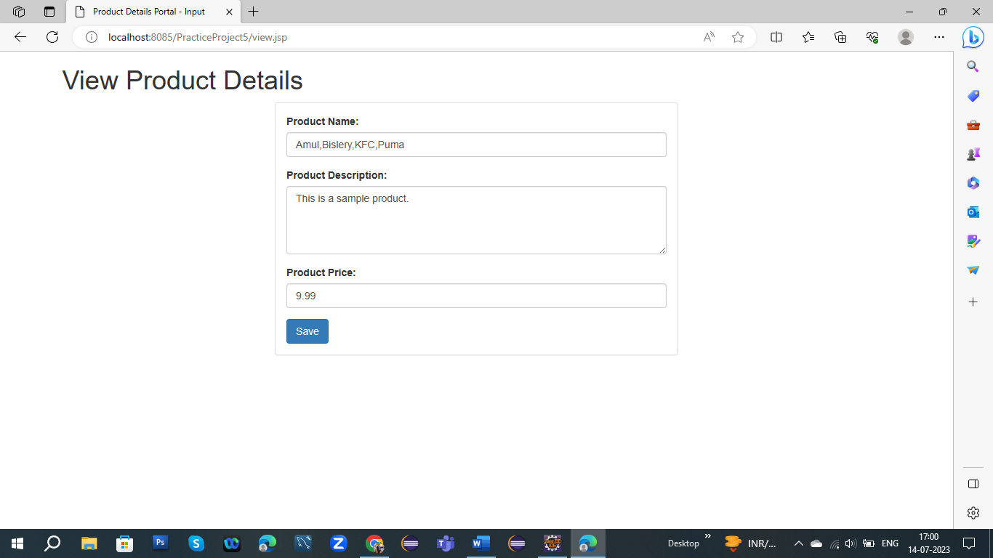

4.After checking if my data is correct then don’t need to change our data but if my data is wrong then we have to change our data

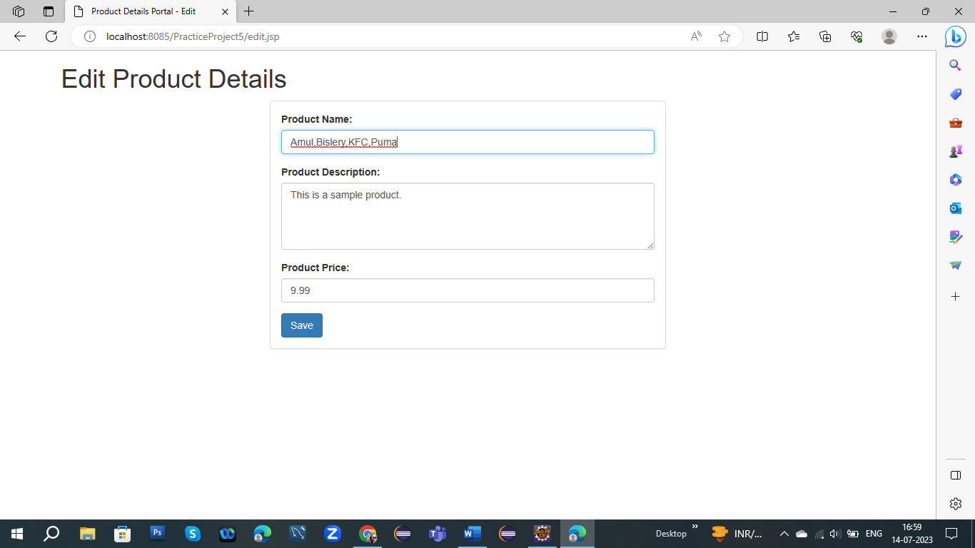

5.And last we get our final output of product details

